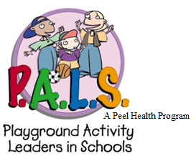
P.A.L.S. Student Leader
Feedback Form

Circle one answer for each question:

- Do you think the students enjoy the activities? Never Sometimes Always

- Do the P.A.L.S. Leaders work well together? Never Sometimes Always

- Are safety concerns dealt with during the games? Never Sometimes Always

- Do the students play fairly? Never Sometimes Always

- Was it difficult to get students to participate? Never Sometimes Always

- Did you understand the instructions for the games? Never Sometimes Always

- Was it easy to teach the students the games? Never Sometimes Always

- Which games are:

Most Popular? Least popular?
- ____________________ 1.______________________
- ____________________ 2. _____________________
- ____________________ 3. _____________________

- What did you learn from being involved in the P.A.L.S. Program?
__________________________________________________________________________________________________________________________________________________________________________________________________________________

- Would you recommend being a P.A.L.S. Leader to someone? Why or why not?
__________________________________________________________________________________________________________________________________________________________________________________________________________________

- How could the program be improved?
__________________________________________________________________________________________________________________________________________________________________________________________________________________

- Additional comments/suggestions?
__________________________________________________________________________________________________________________________________________________________________________________________________________________

