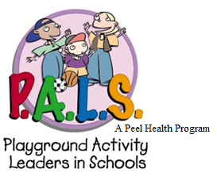
P.A.L.S. Program Details

P.A.L.S. Supervisors are:
(Names of P.A.L.S. Supervisors)

P.A.L.S. Student Leaders are:
(Names of P.A.L.S. Student Leaders)

P.A.L.S. Student Leader Training(s) will be:
(Date(s)/time(s) of training day(s))

P.A.L.S. Program Days will be:
(Day(s) of week/times P.A.L.S. will run at recess)

P.A.L.S. Meetings will be:
(Date(s)/time(s) of P.A.L.S. meeting day(s))

